RESEME

Name of Teaching Staff | Dr. Sanjaykumar Birbal Shinde |  |  | 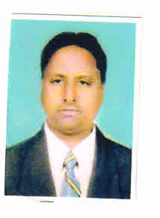
Institute Name | PDEA`S Mahatma Phule Institute of Management and Computer Studies, Hadapsar, Pune.
Designation | Assistant Professor
Department | MBA
Area of Specialization | Marketing &HRM
Date of Joining the  Institute | 01/06/2006
Qualifications with Class/Grade | UG  (B. Com) | First class | PG (PhD,MMS) | First Class
Total Experience in  Years | Teaching | 18 | Industry | 8Yrs
Paper Published | National | 06 | International | 00

